The methods I used
Strategy1： split3mktcap_eliminate_train3000trade500
https://http-proxy.internal:8000/perm3/simreport_python/2ea1f279-d381-4d6f-bbeb-4d887facf334/

In this strategy, based on the benchmark of 21 features:
- Each quarter, after calculating the cs_rank(mktcap) based on the market value of the last day of the quarter, the stock pool is divided into three groups according to its size, and each model is trained within the group. At the same time, a model is also trained in the entire sample space, and the results of the two models are synthesized equally.
- In the group with the lowest market value, three features with missing value ratios exceeding 70% are excluded: 'tsz_bbganalyst', 'analyst_stru1', 'linkup_job_active_count'
- The resulting model is trained on 3000 stocks and trades on 500 stocks.

Strategy2：split3mktcap_eliminate_train3000trade3000
https://http-proxy.internal:8000/perm3/simreport_python/347eff31-bb6f-41b1-a757-308eab60861/

In this strategy,
- I also follow the aforementioned process based on the benchmark of 21 features to complete steps 1 to 3, but it is trained on 3000 stocks and traded on 3000 stocks.

The improvement

The comparison and enhancement of the effects are as follows:
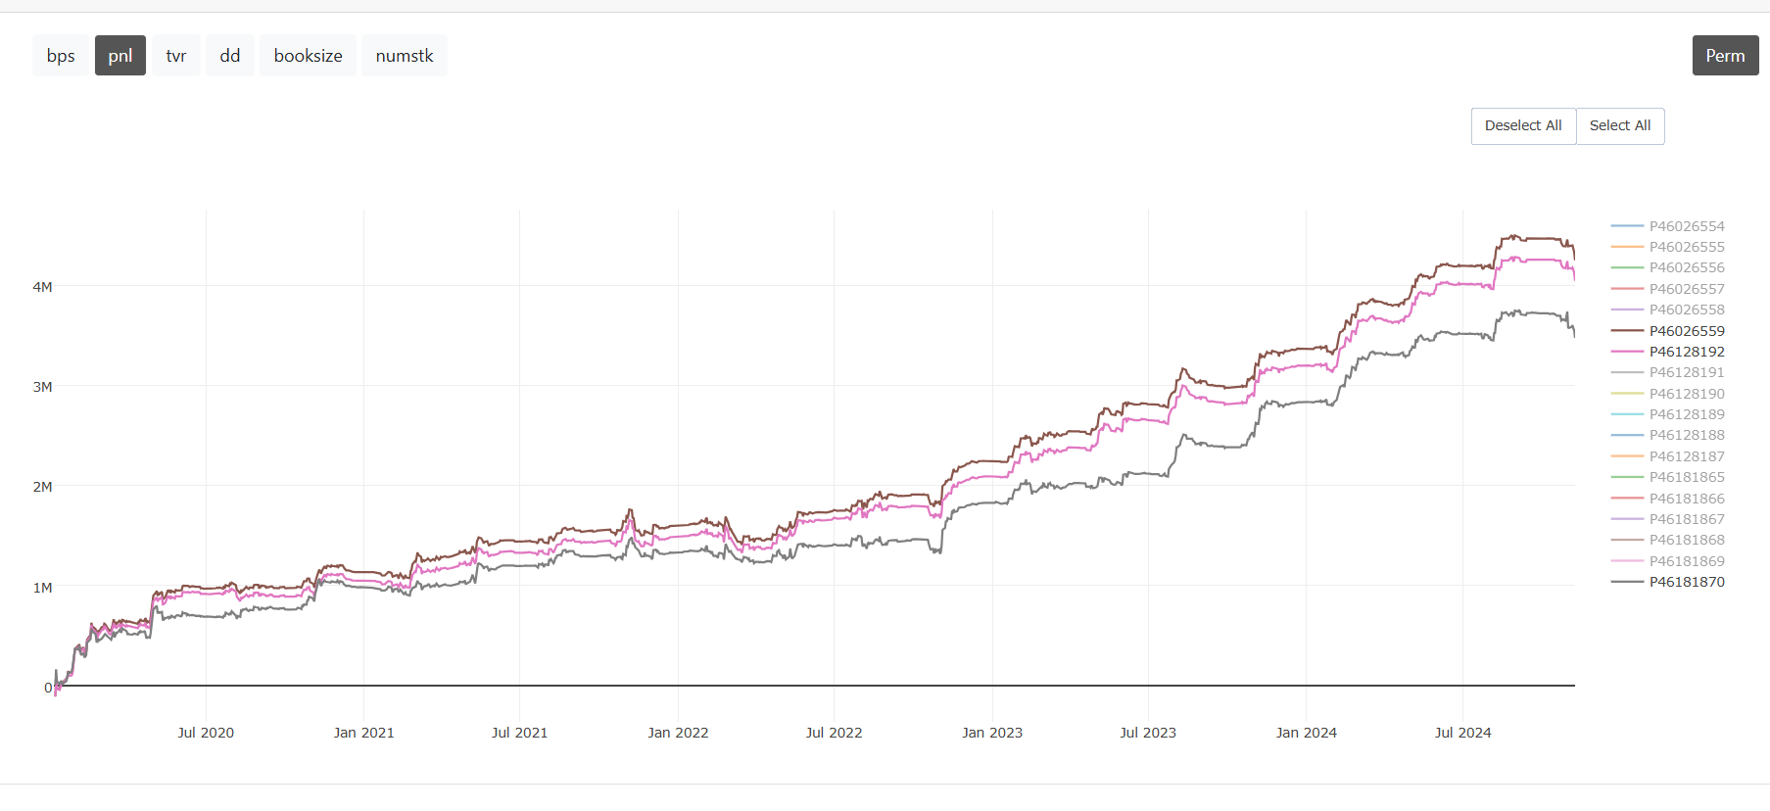
Where：
uuid | fit function | pp function | description
46026559 | fitWenshengliSagarwal91XinwangYunbo39Tpark_EarPred  _21f_n1400_lr1_split3mkt_lowcapnozero | ppWenshengliSagarwal91XinwangYunbo39  Tpark_EarPred_ppfunction | 21bm + 3split mktcap + eliminate 3 features
46128192 | fitWenshengliSagarwal91XinwangYunbo39Tpark_EarPred  _21f_n1400_lr1_split3mktcap_1018_result2 | ppWenshengliSagarwal91XinwangYunbo39  Tpark_EarPred_ppfunction | 21bm + 3split mktcap
46181870 | fitWenshengliSagarwal91XinwangYunbo39Tpark_EarPred  _21f_n1400_lr1 | ppWenshengliSagarwal91XinwangYunbo39  Tpark_EarPred_ppfunction | 21bm

Other univers’ performance is showing below:
Top1750
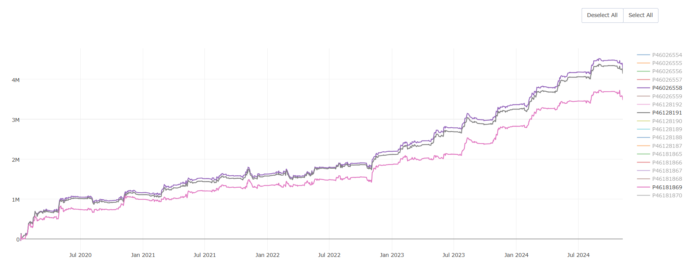
Top1500
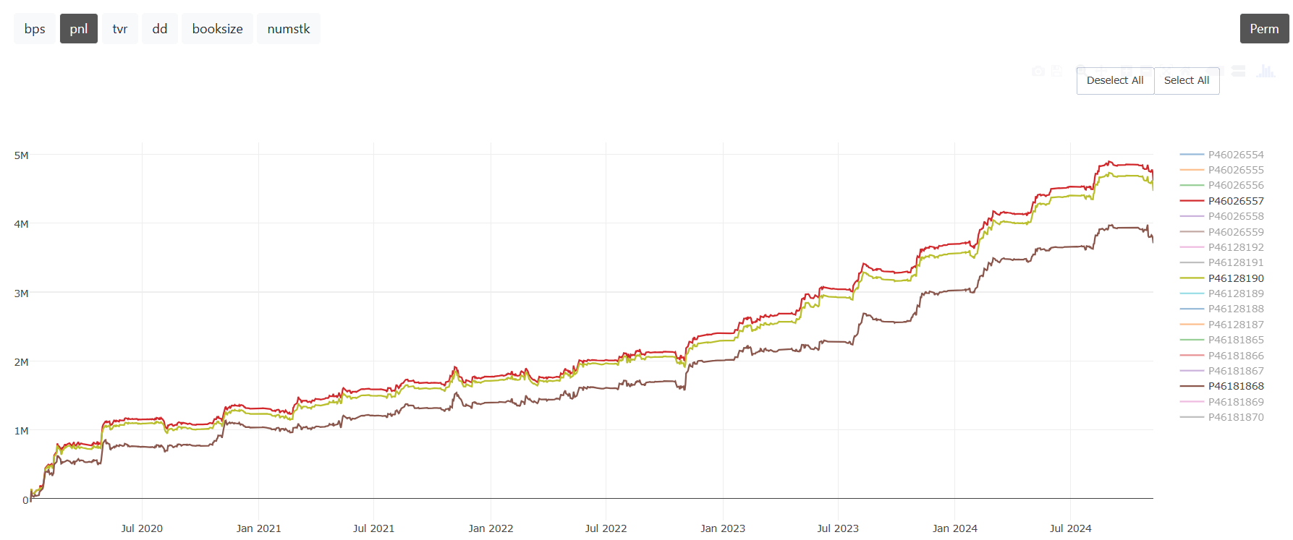
Top1000
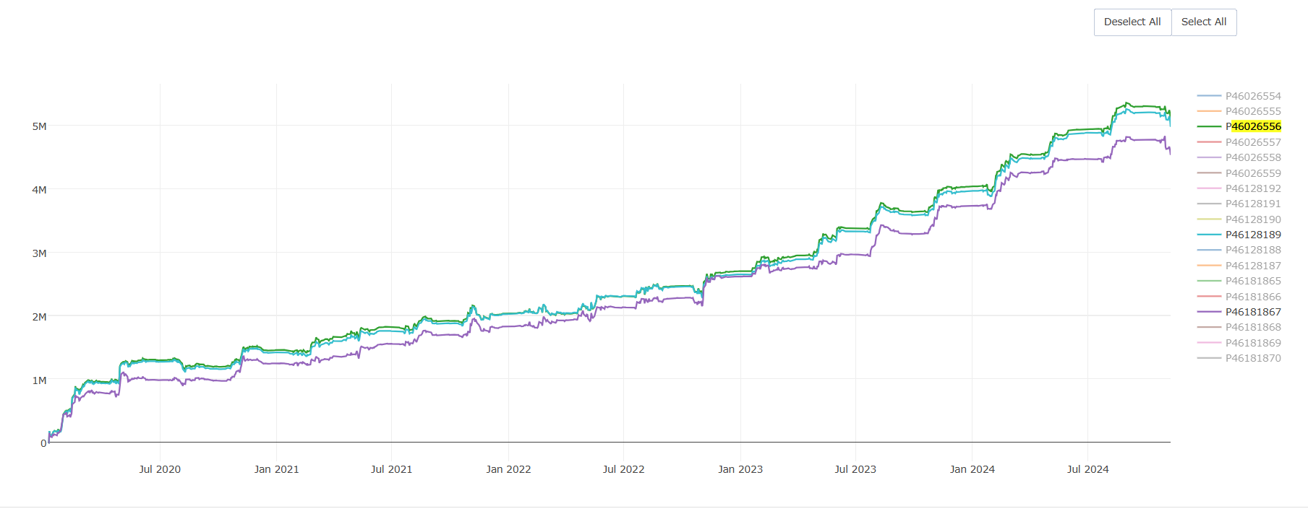

The Reason I choose these 2 strategies
- To complement the 22bm I previously selected, I chose 21bm.
- Overall, the performance of Strategy1 is the best.
- Strategy2 shows the greatest improvement compared to the original top3000 split3mkt strategy.

